**Name : Aarya Tiwari**

**Batch : B2:**

**Roll No. : 16010421119**

**Course: UI Programming**

**Experiment No. : 8**

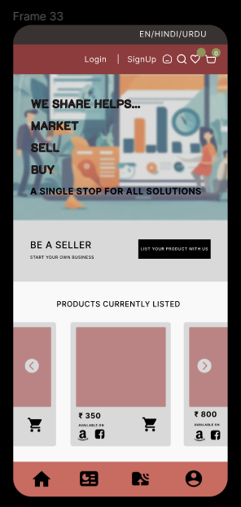

This shows the main page in the mobile UI Interface. Including the navbar , bottom sidebar and the e-marketplace.

The ODOP Mobile UI Interface is a dynamic and accessible platform designed to empower artisans and users on the go. Crafted with a deep appreciation for the region's cultural heritage, this mobile interface provides seamless access to the E-Marketplace, marketing resources, and supply chain management, ensuring that artisans' products and the initiative's mission are just a tap away.

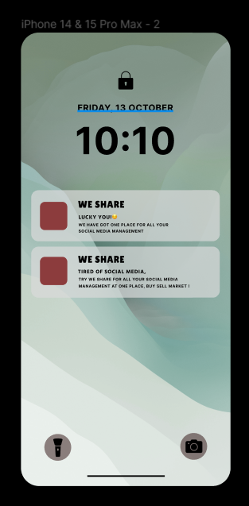

This is a look of how the notifications will look in the home screen of the user.

**Outcomes:**

CO3: Design mobile user interface with UI design patterns

**Conclusion:**

We have learnt about Mobile UI Interfaces.